www.dpairless.com DP-6840IB High Volume Airless Paint Sprayer With Brushless Motor
Hi-boy Cart
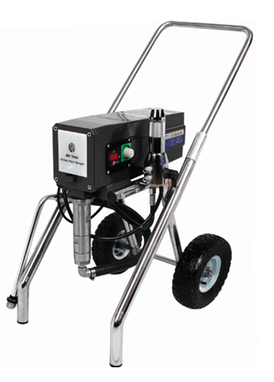
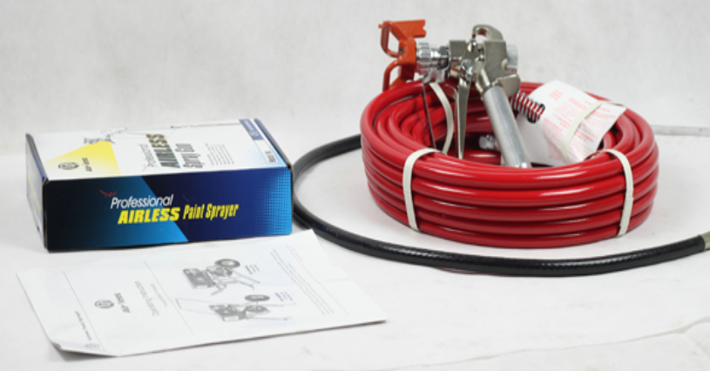
Model No. | DP-6840IB
Type | Electric & Piston Pump
Pressure Controlling | Electronical
Power | 2HP 1500W
Max. Pressure | 230bar/3335psi
Max. Delivery | 3.5L/min
Max. Tip Size | 0.029” (629#) for one gun, or 0.017″ for 2 guns
Electric Motor | Brushless Motor
Contents in package | Airless pump, DP-6371 airless spray gun with 623 tip, 1/4*15m hose, suction tube, lubricating oil, manual.

Description:
- Powered by 2HP 1500W Brushless motor.
- With 3.5L/min(0.92GPM) high flow rate.
- Capable of supporting two guns with 150′ of hose.
- Suitable for spraying all kinds of colorant, varnish, Lacquers & Stains, Medium to high viscosity water-based latex paint,and some oil-based primer, enamel, waterborne, colorant, acrylic, emulsions, varnish, etc.
- Ideal airless sprayer for professionals who want to spray residential areas and light commercial area, interior as well as exterior wall.

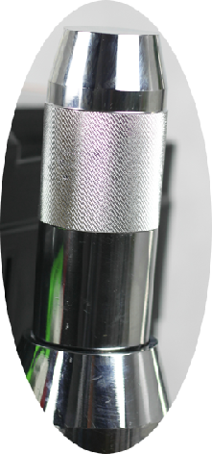
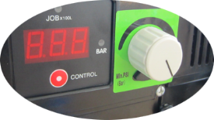
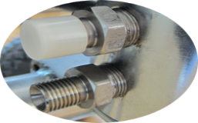
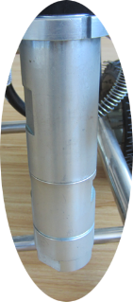
Pump manifold Filter Assembly
Outlet Fitting
Electronic Pressure Control & digital reading
1/4”*15m High Pressure Hose
Airless Spray Gun
Siphon Hose
Manual for DP-6840IB
Fluid pump Assembly
Motor Assembly
Inflating Wheel

